Angular running on Browser

Can be converted to Mobile app from Angular.

Greater than 12 node.js

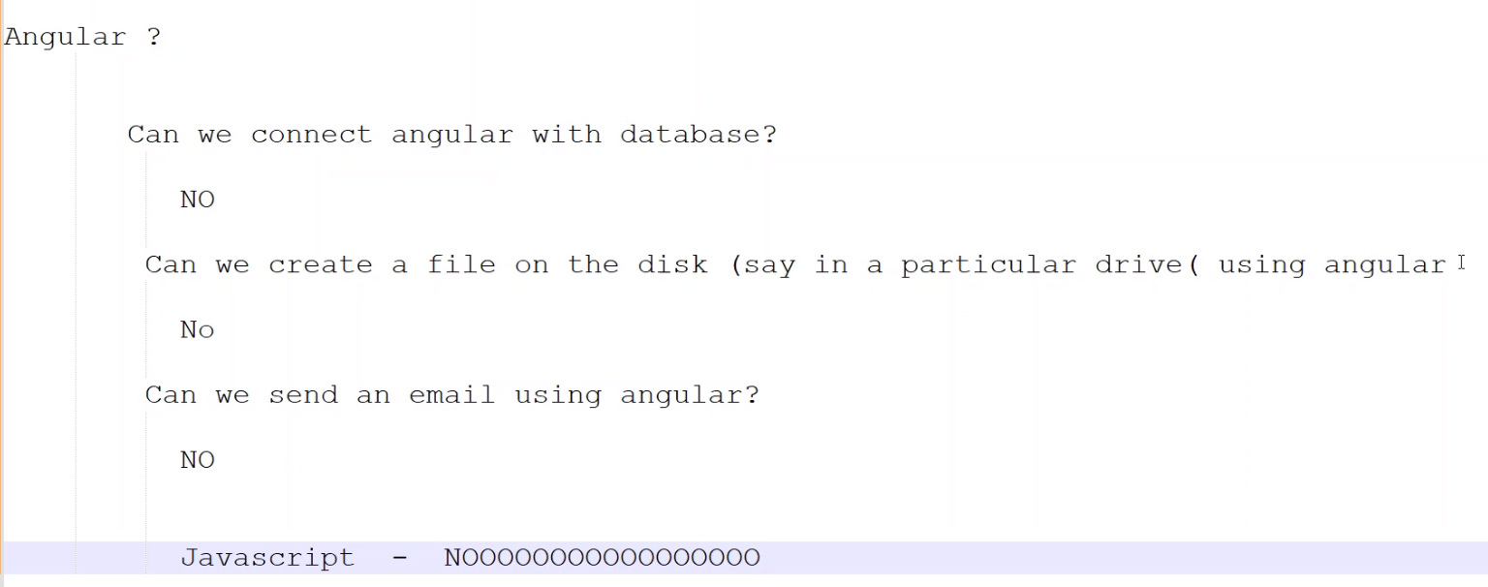

Web SQL – database connected from browser

Node Js – is a platform to run javascript from 2009

Browser – Renders HTML, CSS and execute Javascript

Type script – is not run on browser, but convert to javascript and run on browser

Angular run on browser

Javascript runs on both browser and back-end

HTML 5, CSS 3 defined on 2015.

HTML 5 new features – Notifications , Caching, Storage, Background scripts, drag and drop, drawing

CSS 3 – Responsiveness, Response Design [Responsive **web design** is about creating web pages that look good on all devices! A responsive **web design** will automatically adjust for different screen ...]

Javascript defined by ECMA – European computer manufacturer association.

ECMAScript

Now currently following script is es5. Every year releasing the es scripts

Es6 – released on 2015 [it contains the major changes]…can be called as es2015, es2016….es2022…

PWA – Progressing web Apps are web apps that use service workers, manifests, and other web-platform features in combination with progressive enhancement to give users an experience on par with native apps.

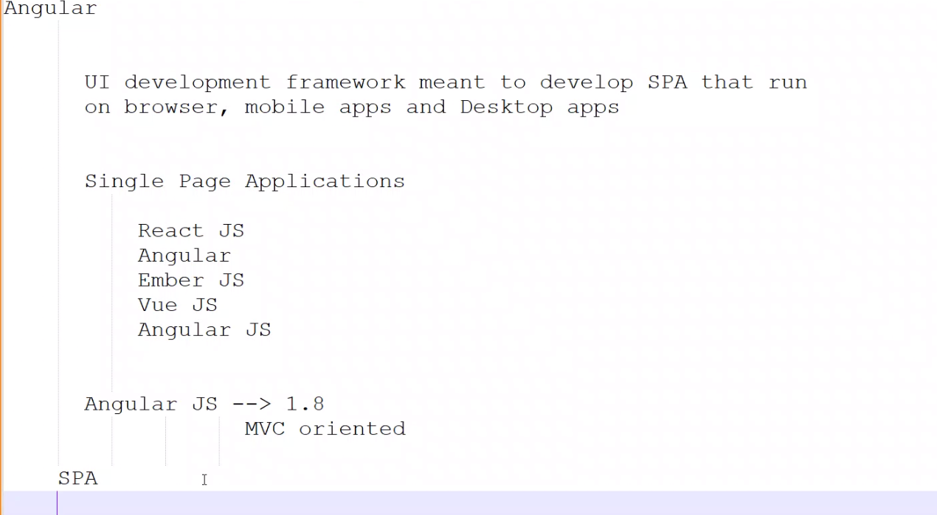

Single Page Application [SPA] - One HTML (Many JS files)

React JS

Angular

Ember JS

Vue JS

Angular JS

In reality,

Development Phase – many html files, type script files, many css files

Production phase – one html file, few js files (max 5 to 20 files), few css files

Add extension – Live server from Preferences in Visual studio code

Enable auto save in VSS from File menu

Javascript run on browser – HTML / CSS running on page - DOM renders [document object model]

Root object is window.

Window.console.log

Window.document.write etc

Javascript – Intepreted language, strictly typed language [No data types definition before hand], it supports string, number, Boolean scaler types,

Literals – for Boolean we true for true, false for false

Literals – for string , define with single quote or double quote

Variables are not declared within function, then it considers as global

Supports Objects, array type [nothing but collection]

[Git Push Local Branch to Remote – How to Publish a New Branch in Git (freecodecamp.org)](https://www.freecodecamp.org/news/git-push-local-branch-to-remote-how-to-publish-a-new-branch-in-git/)

Download the nignx server  
[nginx: download](https://nginx.org/en/download.html) – link

Unzip the nginx. Run the command prompt. Run the start ngnix  
C:\nginx-server\nginx-1.25.0\nginx-1.25.0

In command prompt type it ng…..if it is not installed then put this command in the command prompt

Ng new <appName> – will install all **core packages** of Angular under the folder <appName>

npm install -g @angular/cli

Install typescript anywhere in the system

npm install -g typescript – check whether installed ..the command is tsc

-g means global path. Check the path C:\Users\gganesan5\AppData\Roaming\npm

After downloading the project.. run the command in the VSS npm install.  
This will refer the package.json – find the dependencies of the package and install automatically.

**What is the difference between NPM and Ng?**

NPM is basically a package manager which acts as a dependency provider. Similarly, YARN is another such example. NPM contains and manages many packages and modules, and NG is one such module which is a core module of Angular. functionality to run angular project.

.gitignore – folder --- those folders are not required to upload to git.

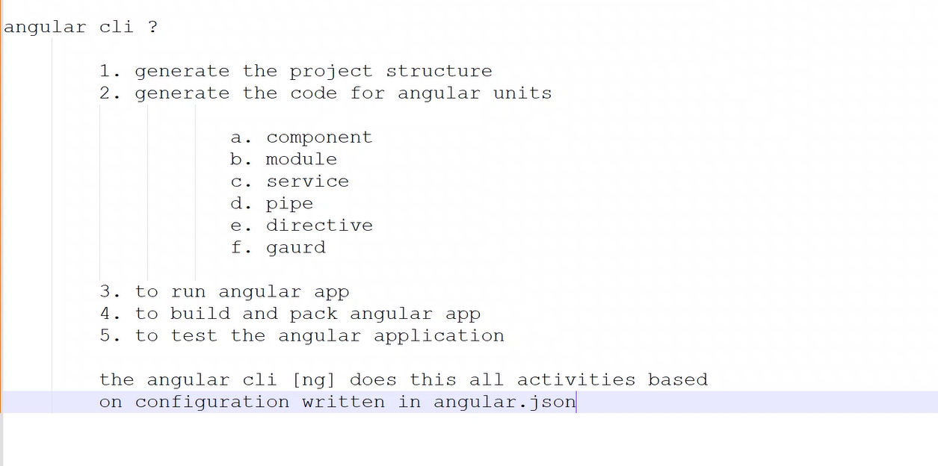

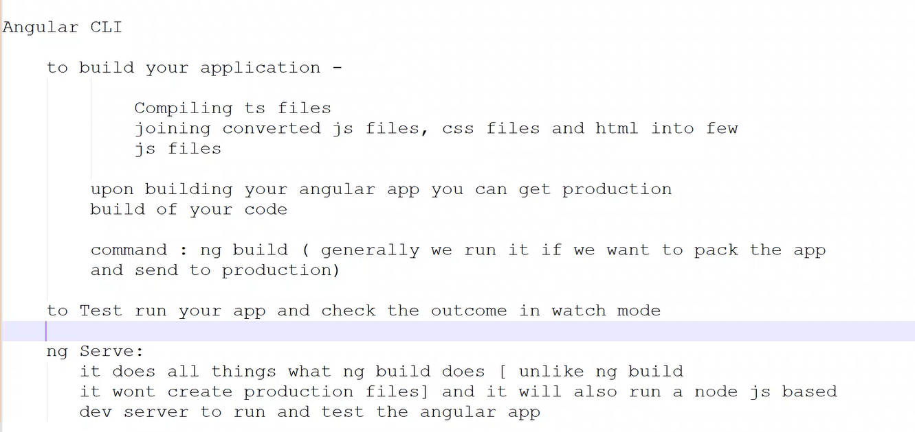

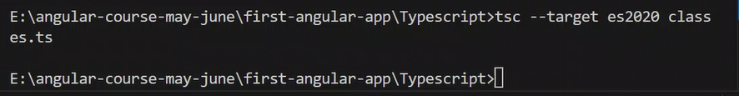

Until mention the ts version in the tsconfig.json, it will compile with es5 version

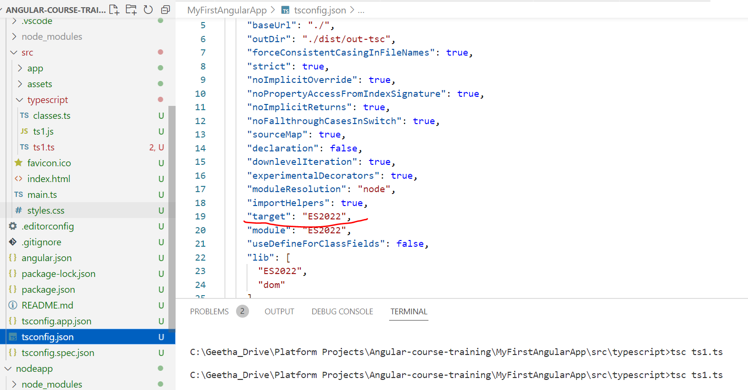

Angular.json -- configuration

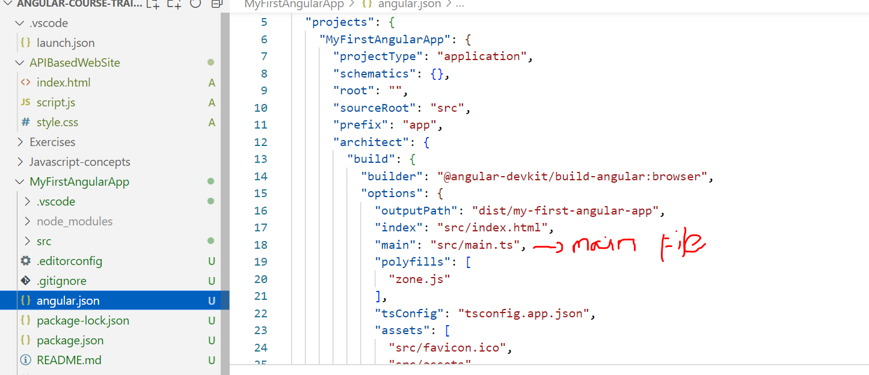

<https://github.com/GGeetha123/AngularCourses>